**Project 1**

**Game Title:**

BlackJack (21) Card Game

**Project Includes:**

Versions 1,2, & 3 of My Development

**Course:**

CSC 5 Summer 2017

**Section:**

45549

**Date Due:**

July 21, 2017

**By:**

Javier Ventura

**Introduction:**

Growing up, my family played many board games, card games, and domino’s games. I am relatively much younger than my cousins, older siblings,and my parents are older than me by a higher age difference than you would normally see. So naturally, my younger brother and I were interested in video games. However, whenever it came to playing any games with the rest of the family, of course, it was “non-tech” related. My dad really enjoys casino type games. So I wanted to try and make a 21 version with what we know about C++.

**Rules:**

21 is a pretty simple game in terms of its logic. A player starts with two cards and based on the worth of each card tries to get as close as possible to the number 21. However, any number above 21 is an automatically loss. The player at a casino is asked if he wants another card or not, where they are allowed to say no if they are under 21 and feel it is not a good idea to ask for another card because of the chance of going over 21.

Every number in the deck is worth itself, so a 2 is worth 2 and a 9 is worth 9. The letters are all worth 10. An Ace is allowed to be declared as 1 or 11. So if you have a letter and an Ace, you win with 21. However if you have a total of 12 and get an Ace it is better to make the Ace worth 1 to not go over. Usually in a casino it is a couple of players versus a dealer who plays an individual battle against each player. That means players are not so much aiming to beat each other but the dealer. So naturally the player

**Summary of Code:**

As mentioned above, the logic is not extremely hard. However, using only concepts we have learned in the class that is on the checklist, then the lines did get repetitive. Most of the code is making sure, that the sums are right as the player gets another card. After the player sees their cards then it asks if they want another card and it displays the card along the previous cards. Many lines were used to declare variables because if a 2 was given in card 1 it is worth 2 but if that card would have been drawn as card 2 then it still has to be worth 2. Getting that to match, along with increasing the possible sum of the cards was a lot of lines using if statements.

Total Lines : 960

Blank and Comment Lines: 100

Variable Lines:92

Library Lines:3

Other Lines: 765

**Version 1:**

Version 1 was mostly just getting the program to run,giving out the cards, yet it is still playable considering that the basic rules are all there. Version one was just getting the two cards and asking for more. So if you go over 21, you lose, if you get 21 you win automatically,. The exception is staying under 21, because there is no one to compare against.

**Version 2:**

Version 2 is a bit more realistic with adding bets and a dealer. At the beginning of the round, the screen prompts the player to enter a bet for the round. If the player wins then their bet is doubled since the dealer will match their bet, just like in a casino. If they lose that round, then their bet is taken by the dealer. The player has his turns first, meaning the dealer's hand is not shown until the player reaches 4 cards or does not want another card. Again, this is similar to a typical casino where the dealer shows his cards after all the players.

**Version 3:**

For Version 3 I again attempted at making the game a bit more realistic and not limiting the game to one round. As most people stay at a table for multiple rounds and convert much more money into chips, than the worth of just one round of betting. So I added a money to chips conversion, into a total pot. From this total pot you can choose how much you want to put forward for the round and if you lose your bet then that amount is subtracted from your total pot. Likewise if you win then your bet is matched and that extra is added to your pot. The bet per round is also checked to make sure you don’t put any amount above what is in your pot. I also added multiple rounds, so you can play without having to rerun the program. The game ends if your pot is 0 or you do not want to play any more.

**Possible Improvements:**

There is a lot of room for improvement for Project 2 and overall just in general as a programmer. I have a lot to learn but nonetheless, this was a learning process in of its own (Loop). In a real casino, when you play and your two initial cards are the same you are allowed to split, put a bet on each card. This is allowing you to play twice in a round. This would be something to try and add. Also the rules for a dealer are that if they are under 17 they have to get another card until they fall in the range of 17-21, if they go over they lose and if they fall in the range then they cannot ask for another, this includes them not being able to ask for another if their two initial cards sum to above 17 and below 21.These rules would be a good addition because as of now, the dealer is just given two cards to compare to the player, and if it is an ace it is just assumed the dealer is using it as an 11 to try and get the dealer as closer to 21 as possible. Also the player is only allowed to ask for 2 cards more than the initial ones given. In BlackJack sometimes this is not a big deal since most games end early but for the exceptions where this is not the case then it is important to add more cards. Another idea is for more players to be involved to simulate an actual table.

**Pseudo Code:**

Include libraries

Declare variables

Input total pot

Input bet for first round

If bet is larger ask for bet again

Give user first two cards

If card one or two is an ace

Ask user to input if they want that card to be worth 1 or 11

If neither is an ace,

values are initialized to zero

If card one or two is a two,

the worth for that card is two

If neither is a two,

the worth of both cards are initialized to zero

If card one or two is a three,

the worth for that card is three

If neither is a three,

the worth of both cards are initialized to zero

If card one or two is a four,

the worth for that card is four

If neither is a four,

the worth of both cards are initialized to zero

If card one or two is a five,

the worth for that card is five

If neither is a five,

the worth of both cards are initialized to zero

If card one or two is a six,

the worth for that card is six

If neither is a six,

the worth of both cards are initialized to zero

If card one or two is a seven,

the worth for that card is seven

If neither is a seven,

the worth of both cards are initialized to zero

If card one or two is an eight,

the worth for that card is an eight

If neither is an eight,

the worth of both cards are initialized to zero

If card one or two is a nine,

the worth for that card is nine

If neither is a nine,

the worth of both cards are initialized to zero

If card one or two is a ten,

the worth for that card is ten

If neither is a ten,

the worth of both cards are initialized to zero

If card one or two is a jack,

the worth for that card is ten

If neither is a jack,

the worth of both cards are initialized to zero

If card one or two is a queen,

the worth for that card is ten

If neither is a queen,

the worth of both cards are initialized to zero

If card one or two is a king,

the worth for that card is ten

If neither is a king,

the worth of both cards are initialized to zero

The sum is all values added together

Display sum

If it is 21,

Player wins, bet is added back to pot

If it is greater than 21

Player loses, bet is subtracted from pot,

If pot is 0

Player can no longer play

If sum is still below 21

Prompt user wants if they want another card

If No

Skip to dealers cards

If Yes

Display last two cards and new one, with new total

If it is 21,

Player wins, bet is added back to pot

If it is greater than 21

Player loses, bet is subtracted from pot,

If pot is 0

Player can no longer play

If sum is still below 21

Prompt user wants if they want another card

If No

Skip to dealers cards

If Yes

Display last three cards and new one, with new total

If it is 21,

Player wins, bet is added back to pot

If it is greater than 21

Player loses, bet is subtracted from pot,

If pot is 0

Player can no longer play

If sum is still below 21

Skip to dealers card now

Display Dealer's cards

Display dealer sum

If it is greater than 21 or lower than player sum,

Player wins, bet is added back to pot

If it is less than 21 but larger than player sum

Player loses, bet is subtracted from pot,

If pot is 0

Player can no longer play

If sum is still below 21 and equal to player sum

Ends in draw, bet is returned, no loss or gain

Prompt user if they would like to play again

If Yes

Return to top of loop, and prompt for bet

If No

End Program

**Flowchart:**

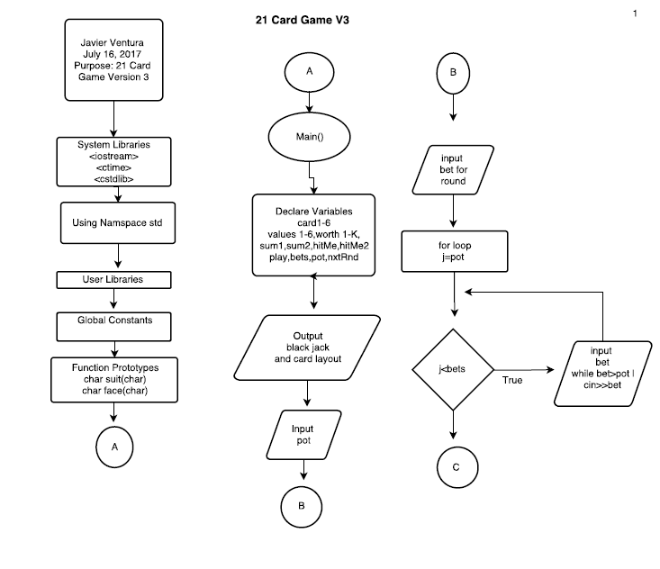

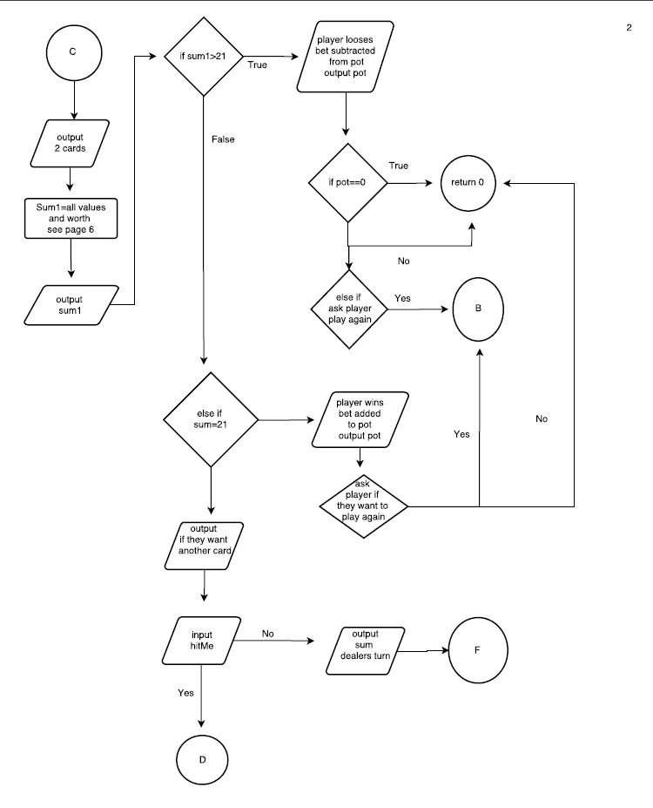

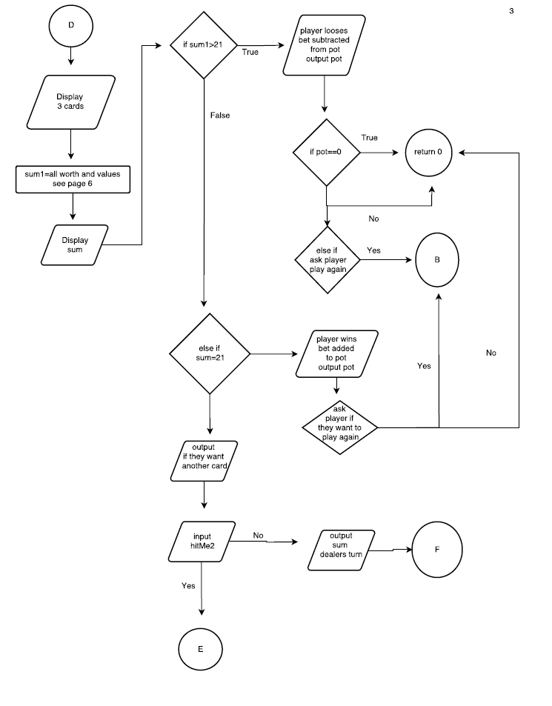

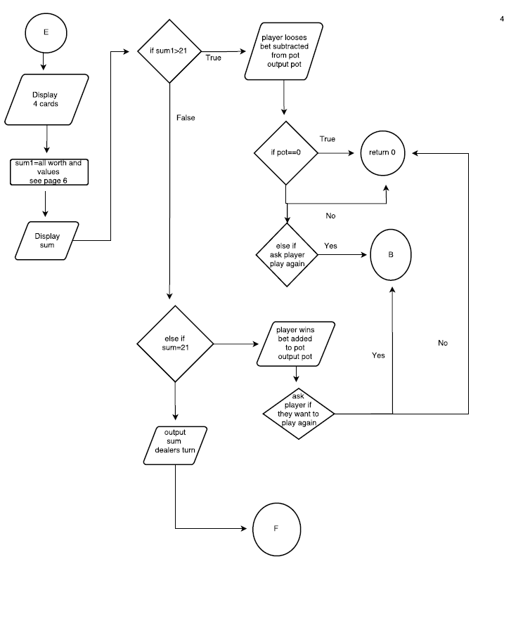

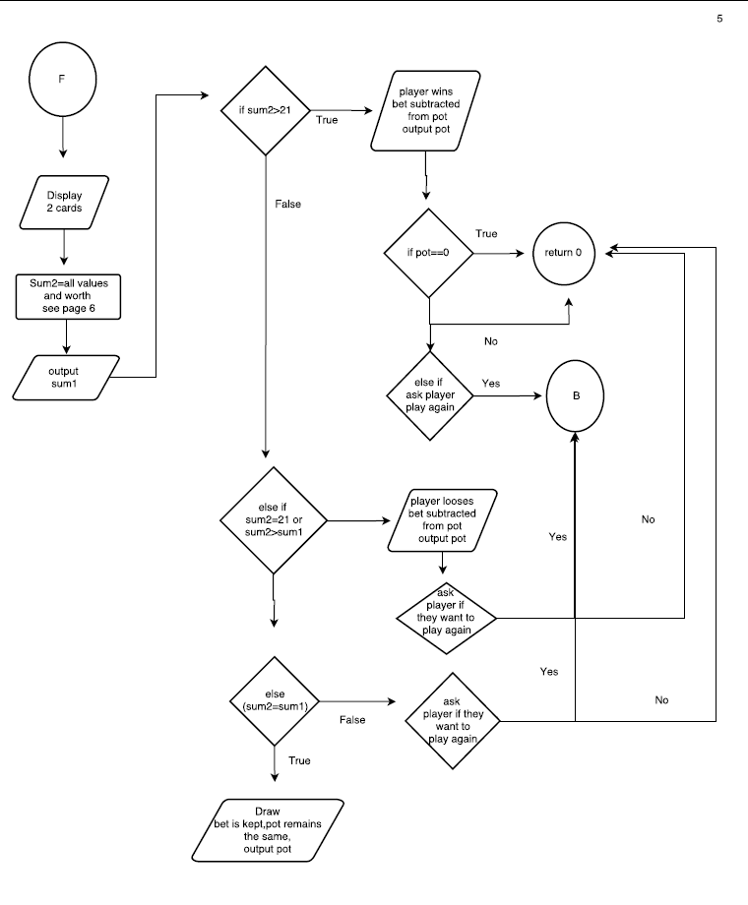

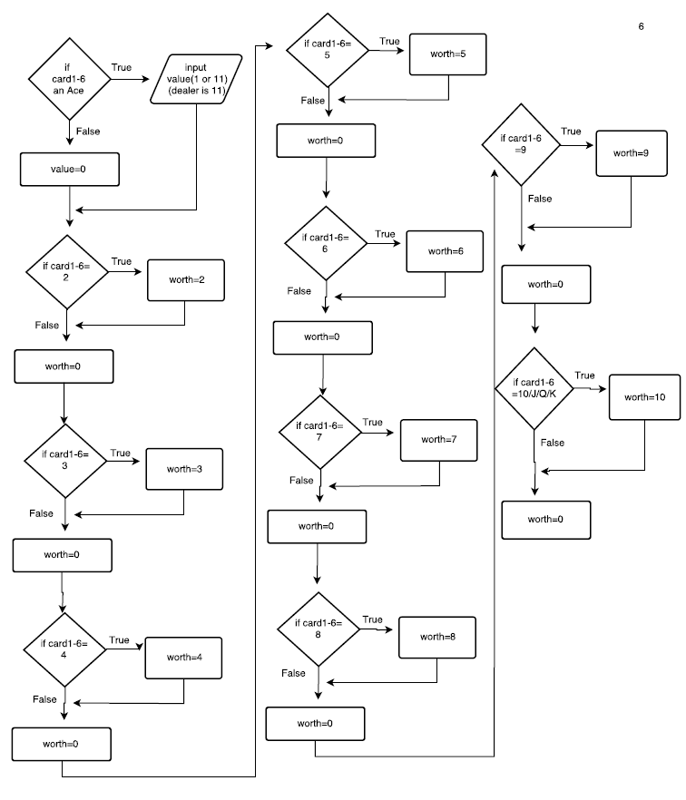

**Code:**

**/\***

**\* File: main.cpp**

**\* Author: Javier Ventura**

**\* Purpose: 21 Card Game V3**

**\* Updates: V2 Dealer is introduced, Player can ask for 2 extra cards,**

**\* compares cards and declares winner, bets are now introduced.**

**\* Created on July 14, 2017, 10:20 PM**

**\*/**

**//System Libraries**

**#include <iostream> //Input - Output Library**

**#include <cstdlib> //Random number library**

**#include <ctime> //Time library**

**using namespace std; //Name-space under which system libraries exist**

**//User Libraries**

**//Global Constants**

**//Function Prototypes**

**char suit(char);**

**char face(char);**

**//Execution begins here**

**int main(int argc, char** argv) {**

**//Declare variables**

**int value1; //If Ace is card 1, value is either 1 or 11**

**int value2; //If Ace is card 2, value is either 1 or 11**

**int value3;**

**int value4;**

**int value5;**

**int value6;**

**unsigned int sum1; //Player Sum**

**unsigned int sum2;**

**int worth21; //If Card 1 is a 2 worth is 2,none drawn worth=0**

**int worth22; //If card 2 is a 2 worth is 2,none drawn worth=0**

**int worth23;**

**int worth24;**

**int worth25;**

**int worth26;**

**int worth31; //If Card 1 is a 3 worth is 3,none drawn worth=0**

**int worth32; //If card 2 is a 3 worth is 3,none drawn worth=0**

**int worth33;**

**int worth34;**

**int worth35;**

**int worth36;**

**int worth41; //If Card 1 is a 4 worth is 4,none drawn worth=0**

**int worth42; //If card 2 is a 4 worth is 4,none drawn worth=0**

**int worth43;**

**int worth44;**

**int worth45;**

**int worth46;**

**int worth51; //If Card 1 is a 5 worth is 5,none drawn worth=0**

**int worth52; //If card 2 is a 5 worth is 5,none drawn worth=0**

**int worth53;**

**int worth54;**

**int worth55;**

**int worth56;**

**int worth61; //If Card 1 is a 6 worth is 6,none drawn worth=0**

**int worth62; //If card 2 is a 6 worth is 6,none drawn worth=0**

**int worth63;**

**int worth64;**

**int worth65;**

**int worth66;**

**int worth71; //If Card 1 is a 7 worth is 7,none drawn worth=0**

**int worth72; //If card 2 is a 7 worth is 7,none drawn worth=0**

**int worth73;**

**int worth74;**

**int worth75;**

**int worth76;**

**int worth81; //If Card 1 is a 8 worth is 8,none drawn worth=0**

**int worth82; //If card 2 is a 8 worth is 8,none drawn worth=0**

**int worth83;**

**int worth84;**

**int worth85;**

**int worth86;**

**int worth91; //If Card 1 is a 9 worth is 9,none drawn worth=0**

**int worth92; //If card 2 is a 9 worth is 9,none drawn worth=0**

**int worth93;**

**int worth94;**

**int worth95;**

**int worth96;**

**int worthT1; //If Card 1 is a 10 worth is 10,none drawn worth=0**

**int worthT2; //If card 2 is a 10 worth is 10,none drawn worth=0**

**int worthT3;**

**int worthT4;**

**int worthT5;**

**int worthT6;**

**int worthJ1; //If Card 1 is a J worth is 10,none drawn worth=0**

**int worthJ2; //If card 2 is a J worth is 2,none drawn worth=0**

**int worthJ3;**

**int worthJ4;**

**int worthJ5;**

**int worthJ6;**

**int worthQ1; //If Card 1 is a Q worth is 10,none drawn worth=0**

**int worthQ2; //If card 2 is a Q worth is 10,none drawn worth=0**

**int worthQ3;**

**int worthQ4;**

**int worthQ5;**

**int worthQ6;**

**int worthK1; //If Card 1 is a K worth is 10,none drawn worth=0**

**int worthK2; //If card 2 is a K worth is 10,none drawn worth=0**

**int worthK3;**

**int worthK4;**

**int worthK5;**

**int worthK6;**

**char hitMe;**

**char hitMe2;**

**bool play = true;**

**float bets;**

**float pot;**

**char nxtRnd;**

**cout<<"Black Jack"<<endl;**

**cout<<"Card Layout: ";**

**cout<<"D for Diamonds, S for Spades,C for Clubs,H for Hearts"<<endl;**

**cout<<endl;**

**cout<<"Enter The Amount for your BlackJack Pot: $";**

**cin>>pot;**

**cout<<endl;**

**do{**

**srand(static_cast<unsigned int>(time(0)));**

**char card1=rand()%52+1; //One of the two initial cards for player**

**char card2=rand()%52+1; //One of the two initial cards for player**

**char card3=rand()%52+1;**

**char card4=rand()%51+1;**

**char card5=rand()%51+1;**

**char card6=rand()%51+1;**

**card1!=card2;**

**card2!=card3;**

**card3!=card4;**

**card4!=card5;**

**card5!=card6;**

**cout<<"Enter Bet for round: $";**

**cin>>bets;**

**cout<<endl;**

**for(int j=pot;j<bets;){**

**cout<<"Sorry You don't have that much in your pot.";**

**cout<<" Enter Bet Again"<<endl;**

**cin>>bets;**

**cout<<endl;**

**while(bets>pot){**

**cout<<"Sorry You don't have that much in your pot.";**

**cout<<" Enter Bet Again"<<endl;**

**cin>>bets;**

**cout<<endl;**

**}**

**}**

**cout<<face(card1)<<suit(card1)<<" "<<face(card2)<<suit(card2)<<endl;**

**if(card1==1 || card1==14 || card1==27 || card1==40){**

**cout<<endl;**

**cout<<"Ace can be 1 or 11."<<endl;**

**cin>>value1;**

**while(value1!=1&&value1!=11){**

**cout<<"1 or 11"<<endl;**

**cin>>value1;**

**cout<<endl;**

**}**

**}**

**else{**

**value1=0;**

**}**

**if(card2==1 || card2==14 || card2==27 || card2==40){**

**cout<<endl;**

**cout<<"Ace can be 1 or 11. "<<endl;**

**cin>>value2;**

**while(value2!=1&&value2!=11){**

**cout<<"1 or 11"<<endl;**

**cin>>value2;**

**cout<<endl;**

**}**

**}**

**else{**

**value2=0;**

**}**

**if(card1==2 || card1==15 || card1==28 || card1==41){**

**worth21=2;**

**}**

**else{**

**worth21=0;**

**}**

**if(card2==2 || card2==15 || card2==28 || card2==41){**

**worth22=2;**

**}**

**else{**

**worth22=0;**

**}**

**if(card1==3 || card1==16 || card1==29 || card1==42){**

**worth31=3;**

**}**

**else{**

**worth31=0;**

**}**

**if(card2==3 || card2==16 || card2==29 || card2==42){**

**worth32=3;**

**}**

**else{**

**worth32=0;**

**}**

**if(card1==4 || card1==17 || card1==30 || card1==43){**

**worth41=4;**

**}**

**else{**

**worth41=0;**

**}**

**if(card2==4 || card2==17 || card2==30 || card2==43){**

**worth42=4;**

**}**

**else{**

**worth42=0;**

**}**

**if(card1==5 || card1==18 || card1==31 || card1==44){**

**worth51=5;**

**}**

**else{**

**worth51=0;**

**}**

**if(card2==5 || card2==18 || card2==31 || card2==44){**

**worth52=5;**

**}**

**else{**

**worth52=0;**

**}**

**if(card1==6 || card1==19 || card1==32 || card1==45){**

**worth61=6;**

**}**

**else{**

**worth61=0;**

**}**

**if(card2==6 || card2==19 || card2==32 || card2==45){**

**worth62=6;**

**}**

**else{**

**worth62=0;**

**}**

**if(card1==7 || card1==20 || card1==33 || card1==46){**

**worth71=7;**

**}**

**else{**

**worth71=0;**

**}**

**if(card2==7 || card2==20 || card2==33 || card2==46){**

**worth72=7;**

**}**

**else{**

**worth72=0;**

**}**

**if(card1==8 || card1==21 || card1==34 || card1==47){**

**worth81=8;**

**}**

**else{**

**worth81=0;**

**}**

**if(card2==8 || card2==21 || card2==34 || card2==47){**

**worth82=8;**

**}**

**else{**

**worth82=0;**

**}**

**if(card1==9 || card1==22 || card1==35 || card1==48){**

**worth91=9;**

**}**

**else{**

**worth91=0;**

**}**

**if(card2==9 || card2==22 || card2==35 || card2==48){**

**worth92=9.0f;**

**}**

**else{**

**worth92=0;**

**}**

**if(card1==10 || card1==23 || card1==36 || card1==49){**

**worthT1=10.0f;**

**}**

**else{**

**worthT1=0;**

**}**

**if(card2==10 || card2==23 || card2==36 || card2==49){**

**worthT2=10.0f;**

**}**

**else{**

**worthT2=0;**

**}**

**if(card1==11 || card1==24 || card1==37 || card1==50){**

**worthJ1=10.0f;**

**}**

**else{**

**worthJ1=0;**

**}**

**if(card2==11 || card2==24 || card2==37 || card2==50){**

**worthJ2=10.0f;**

**}**

**else{**

**worthJ2=0;**

**}**

**if(card1==12 || card1==25 || card1==38 || card1==51){**

**worthQ1=10.0f;**

**}**

**else{**

**worthQ1=0;**

**}**

**if(card2==12 || card2==25 || card2==38 || card2==51){**

**worthQ2=10.0f;**

**}**

**else{**

**worthQ2=0;**

**}**

**if(card1==13 || card1==26 || card1==39 || card1==52){**

**worthK1=10.0f;**

**}**

**else{**

**worthK1=0;**

**}**

**if(card2==13 || card2==26 || card2==39 || card2==52){**

**worthK2=10.0f;**

**}**

**else{**

**worthK2=0;**

**}**

**sum1=value1+value2+worth21+worth22+worth31+worth32+worth41+worth42+worth51**

**+worth52+worth61+worth62+worth71+worth72+worth81+worth82+worth91+worth92+**

**worthT1+worthT2+worthJ1+worthJ2+worthQ1+worthQ2+worthK1+worthK2;**

**cout<<"Sum: "<<sum1<<endl;**

**cout<<endl;**

**if(sum1>21){**

**cout<<"You went over 21! Sorry You Lose!"<<endl;**

**cout<<"You Lost: $"<<bets<<endl;**

**pot=pot-bets;**

**cout<<"Your Pot: $"<<pot<<endl;**

**if(pot==0){**

**cout<<"Sorry, Your Pot is empty.Come Back Next Time"<<endl;**

**return 0;**

**}**

**}**

**else if(sum1==21){**

**cout<<"21!! You win! "<<endl;**

**cout<<endl;**

**cout<<"Earnings (This Round): $"<<bets<<endl;**

**pot=pot+bets;**

**cout<<"Your Pot: $"<<endl;**

**}**

**else{**

**cout<<endl;**

**cout<<"Do you want another card? Enter Y for Yes,N for No"<<endl;**

**cin>>hitMe;**

**cout<<endl;**

**//Input Validation**

**while(hitMe!='Y' && hitMe!='N'){**

**cout<<"Y for Yes and N for No"<<endl;**

**cin>>hitMe;**

**cout<<endl;**

**}**

**}**

**if(hitMe=='Y'){**

**cout<<face(card1)<<suit(card1)<<" "<<face(card2)<<suit(card2);**

**cout<<" "<<face(card3)<<suit(card3)<<endl;**

**if(card3==1 || card3==14 || card3==27 || card3==40){**

**cout<<endl;**

**cout<<"Ace can be 1 or 11."<<endl;**

**cin>>value3;**

**cout<<endl;**

**while(value3!=1&&value3!=11){**

**cout<<"1 or 11"<<endl;**

**cin>>value3;**

**cout<<endl;**

**}**

**}**

**else{**

**value3=0;**

**}**

**if(card3==2 || card3==15 || card3==28 || card3==41){**

**worth23=2;**

**}**

**else{**

**worth23=0;**

**}**

**if(card3==3 || card3==16 || card3==29 || card3==42){**

**worth33=3;**

**}**

**else{**

**worth33=0;**

**}**

**if(card3==4 || card3==17 || card3==30 || card3==43){**

**worth43=4;**

**}**

**else{**

**worth43=0;**

**}**

**if(card3==5 || card3==18 || card3==31 || card3==44){**

**worth53=2;**

**}**

**else{**

**worth53=0;**

**}**

**if(card3==6 || card3==19 || card3==32 || card3==45){**

**worth63=6;**

**}**

**else{**

**worth63=0;**

**}**

**if(card3==7 || card3==20 || card3==33 || card3==46){**

**worth73=7;**

**}**

**else{**

**worth73=0;**

**}**

**if(card3==8 || card3==21 || card3==34 || card3==47){**

**worth83=4;**

**}**

**else{**

**worth83=0;**

**}**

**if(card3==9 || card3==22 || card3==35 || card3==48){**

**worth93=4;**

**}**

**else{**

**worth93=0;**

**}**

**if(card3==10 || card3==23 || card3==36 || card3==49){**

**worthT3=5;**

**}**

**else{**

**worthT3=0;**

**}**

**if(card3==11 || card3==24 || card3==37 || card3==50){**

**worthJ3=10;**

**}**

**else{**

**worthJ3=0;**

**}**

**if(card3==12 || card3==25 || card3==38 || card3==51){**

**worthQ3=10;**

**}**

**else{**

**worthQ3=0;**

**}**

**if(card3==13 || card3==26 || card3==39 || card3==52){**

**worthK3=10;**

**}**

**else{**

**worthK3=0;**

**}**

**sum1=value1+value2+worth21+worth22+worth31+worth32+worth41+worth42+**

**worth51+worth52+worth61+worth62+worth71+worth72+worth81+worth82+**

**worth91+worth92+worthT1+worthT2+worthJ1+worthJ2+worthQ1+worthQ2+**

**worthK1+worthK2+worthK3+worthQ3+worthJ3+worthT3+worth93+worth83+**

**worth73+worth63+worth53+worth43+worth33+worth23+value3;**

**cout<<"Sum: "<<sum1<<endl;**

**cout<<endl;**

**if(sum1>21){**

**cout<<"You went over 21! Sorry You Lose!"<<endl;**

**cout<<"You Lost: $"<<bets<<endl;**

**cout<<endl;**

**pot=pot-bets;**

**cout<<"Your Pot: $"<<pot<<endl;**

**cout<<endl;**

**if(pot==0){**

**cout<<"Sorry, Your Pot is empty.Come Back Next Time"<<endl;**

**return 0;**

**}**

**}**

**else if(sum1==21){**

**cout<<"21!! You win! "<<endl;**

**cout<<endl;**

**cout<<"Earnings (This Round): $"<<bets<<endl;**

**pot=pot+bets;**

**cout<<"Your Pot: $"<<pot<<endl;**

**cout<<endl;**

**}**

**else{**

**cout<<" "<<endl;**

**cout<<"Do you want another card? Enter Y for Yes,N for No"<<endl;**

**cin>>hitMe2;**

**cout<<endl;**

**while(hitMe2!='Y' && hitMe2!='N'){**

**cout<<"Y for Yes and N for No"<<endl;**

**cin>>hitMe2;**

**cout<<endl;**

**}**

**}**

**if(hitMe2=='Y'){**

**cout<<face(card1)<<suit(card1)<<" "<<face(card2)<<suit(card2);**

**cout<<" "<<face(card3)<<suit(card3)<<" "<<face(card4)**

**<<suit(card4)<<endl;**

**if(card4==1 || card4==14 || card4==27 || card4==40){**

**cout<<endl;**

**cout<<"Ace can be 1 or 11."<<endl;**

**cin>>value4;**

**cout<<endl;**

**while(value4!=1&&value4!=11){**

**cout<<"1 or 11"<<endl;**

**cin>>value4;**

**cout<<endl;**

**}**

**}**

**else{**

**value4=0;**

**}**

**if(card4==2 || card4==15 || card4==28 || card4==41){**

**worth24=2;**

**}**

**else{**

**worth24=0;**

**}**

**if(card4==3 || card4==16 || card4==29 || card4==42){**

**worth34=3;**

**}**

**else{**

**worth34=0;**

**}**

**if(card4==4 || card4==17 || card4==30 || card4==43){**

**worth44=4;**

**}**

**else{**

**worth44=0;**

**}**

**if(card4==5 || card4==18 || card4==31 || card4==44){**

**worth54=5;**

**}**

**else{**

**worth54=0;**

**}**

**if(card4==6 || card4==19 || card4==32 || card4==45){**

**worth64=6;**

**}**

**else{**

**worth64=0;**

**}**

**if(card4==7 || card4==20 || card4==33 || card4==46){**

**worth74=7;**

**}**

**else{**

**worth74=0;**

**}**

**if(card4==8 || card4==21 || card4==34 || card4==47){**

**worth84=8;**

**}**

**else{**

**worth84=0;**

**}**

**if(card4==9 || card4==22 || card4==35 || card4==48){**

**worth94=9;**

**}**

**else{**

**worth94=0;**

**}**

**if(card4==10 || card4==23 || card4==36 || card4==49){**

**worthT4=10;**

**}**

**else{**

**worthT4=0;**

**}**

**if(card4==11 || card4==24 || card4==37 || card4==50){**

**worthJ4=10;**

**}**

**else{**

**worthJ4=0;**

**}**

**if(card4==12 || card4==25 || card4==38 || card4==51){**

**worthQ4=10;**

**}**

**else{**

**worthQ4=0;**

**}**

**if(card4==13 || card4==26 || card4==39 || card4==52){**

**worthK4=10;**

**}**

**else{**

**worthK4=0;**

**}**

**sum1=value1+value2+worth21+worth22+worth31+worth32+worth41+worth42+**

**worth51+worth52+worth61+worth62+worth71+worth72+worth81+worth82+**

**worth91+worth92+worthT1+worthT2+worthJ1+worthJ2+worthQ1+worthQ2+**

**worthK1+worthK2+worthK3+worthQ3+worthJ3+worthT3+worth93+worth83+**

**worth73+worth63+worth53+worth43+worth33+worth23+value3+value4+**

**worth24+worth34+worth44+worth54+worth64+worth74+worth84+worth94+**

**worthT4+worthJ4+worthQ4+worthK4;**

**cout<<"Sum: "<<sum1<<endl;**

**cout<<endl;**

**if(sum1>21){**

**cout<<"You went over 21! Sorry You Lose!"<<endl;**

**cout<<endl;**

**cout<<"You Lost: $0"<<endl;**

**pot=pot-bets;**

**cout<<"Your Pot: $"<<pot<<endl;**

**if(pot==0){**

**cout<<"Sorry, Your Pot is empty.Come Back Next Time";**

**cout<<endl;**

**return 0;**

**}**

**}**

**else if(sum1==21){**

**cout<<"21!! You Win!!"<<endl;**

**cout<<endl;**

**cout<<"Earnings (This Round): $"<<bets<<endl;**

**pot=pot+bets;**

**cout<<"Your Pot: $"<<pot<<endl;**

**}**

**else{**

**cout<<endl;**

**cout<<"You stayed at: "<<sum1<<endl;**

**cout<<endl;**

**cout<<"Dealers Turn"<<endl;**

**cout<<endl;**

**}**

**}**

**else if(hitMe2=='N'){**

**cout<<endl;**

**cout<<"You stayed at: "<<sum1<<endl;**

**cout<<endl;**

**cout<<"Dealers Turn"<<endl;**

**cout<<endl;**

**}**

**}**

**else if(hitMe=='N'){**

**cout<<endl;**

**cout<<"You stayed at: "<<sum1<<endl;**

**cout<<endl;**

**cout<<"Dealers Turn"<<endl;**

**cout<<endl;**

**}**

**if(sum1<21){**

**cout<<"Dealers Cards:"<<endl;**

**cout<<face(card5)<<suit(card5)<<" "<<face(card6)<<suit(card6)<<endl;**

**if(card5==1 || card5==14 || card5==27 || card5==40){**

**cout<<endl;**

**cout<<"Ace can be 1 or 11."<<endl;**

**cout<<"11"<<endl;**

**cout<<endl;**

**value5=11;**

**}**

**else{**

**value5=0;**

**}**

**if(card6==1 || card6==14 || card6==27 || card6==40){**

**cout<<endl;**

**cout<<"Ace can be 1 or 11. "<<endl;**

**cout<<"11"<<endl;**

**cout<<endl;**

**value6=11;**

**}**

**else{**

**value6=0;**

**}**

**if(card5==2 || card5==15 || card5==28 || card5==41){**

**worth25=2;**

**}**

**else{**

**worth25=0;**

**}**

**if(card6==2 || card6==15 || card6==28 || card6==41){**

**worth26=2;**

**}**

**else{**

**worth26=0;**

**}**

**if(card5==3 || card5==16 || card5==29 || card5==42){**

**worth35=3;**

**}**

**else{**

**worth35=0;**

**}**

**if(card6==3 || card6==16 || card6==29 || card6==42){**

**worth36=3;**

**}**

**else{**

**worth36=0;**

**}**

**if(card5==4 || card5==17 || card5==30 || card5==43){**

**worth45=4;**

**}**

**else{**

**worth45=0;**

**}**

**if(card6==4 || card6==17 || card6==30 || card6==43){**

**worth46=4;**

**}**

**else{**

**worth46=0;**

**}**

**if(card5==5 || card5==18 || card5==31 || card5==44){**

**worth55=5;**

**}**

**else{**

**worth55=0;**

**}**

**if(card6==5 || card6==18 || card6==31 || card6==44){**

**worth56=5;**

**}**

**else{**

**worth56=0;**

**}**

**if(card5==6 || card5==19 || card5==32 || card5==45){**

**worth65=6;**

**}**

**else{**

**worth65=0;**

**}**

**if(card6==6 || card6==19 || card6==32 || card6==45){**

**worth66=6;**

**}**

**else{**

**worth66=0;**

**}**

**if(card5==7 || card5==20 || card5==33 || card5==46){**

**worth75=7;**

**}**

**else{**

**worth75=0;**

**}**

**if(card6==7 || card6==20 || card6==33 || card6==46){**

**worth76=7;**

**}**

**else{**

**worth76=0;**

**}**

**if(card5==8 || card5==21 || card5==34 || card5==47){**

**worth85=8;**

**}**

**else{**

**worth85=0;**

**}**

**if(card6==8 || card6==21 || card6==34 || card6==47){**

**worth86=8;**

**}**

**else{**

**worth86=0;**

**}**

**if(card5==9 || card5==22 || card5==35 || card5==48){**

**worth95=9;**

**}**

**else{**

**worth95=0;**

**}**

**if(card6==9 || card6==22 || card6==35 || card6==48){**

**worth96=9.0f;**

**}**

**else{**

**worth96=0;**

**}**

**if(card5==10 || card5==23 || card5==36 || card5==49){**

**worthT5=10.0f;**

**}**

**else{**

**worthT5=0;**

**}**

**if(card6==10 || card6==23 || card6==36 || card6==49){**

**worthT6=10.0f;**

**}**

**else{**

**worthT6=0;**

**}**

**if(card5==11 || card5==24 || card5==37 || card5==50){**

**worthJ5=10.0f;**

**}**

**else{**

**worthJ5=0;**

**}**

**if(card6==11 || card6==24 || card6==37 || card6==50){**

**worthJ6=10.0f;**

**}**

**else{**

**worthJ6=0;**

**}**

**if(card5==12 || card5==25 || card5==38 || card5==51){**

**worthQ5=10.0f;**

**}**

**else{**

**worthQ5=0;**

**}**

**if(card6==12 || card6==25 || card6==38 || card6==51){**

**worthQ6=10.0f;**

**}**

**else{**

**worthQ6=0;**

**}**

**if(card5==13 || card5==26 || card5==39 || card5==52){**

**worthK5=10.0f;**

**}**

**else{**

**worthK5=0;**

**}**

**if(card6==13 || card6==26 || card6==39 || card6==52){**

**worthK6=10.0f;**

**}**

**else{**

**worthK6=0;**

**}**

**sum2=value5+value6+worth25+worth26+worth35+worth36+worth45+worth46**

**+worth55+worth56+worth65+worth66+worth75+worth76+worth85+worth86+**

**worth95+worth96+worthT5+worthT6+worthJ5+worthJ6+worthQ5+worthQ6+**

**worthK5+worthK6;**

**cout<<"Dealer Sum: "<<sum2<<endl;**

**if(sum1>sum2){**

**cout<<endl;**

**cout<<"Player Wins!"<<endl;**

**cout<<endl;**

**cout<<"Earnings (This Round): $"<<bets<<endl;**

**pot=pot+bets;**

**cout<<"Your Pot: $"<<pot<<endl;**

**cout<<endl;**

**}**

**if(sum2>sum1){**

**cout<<endl;**

**cout<<"Dealer Wins!"<<endl;**

**cout<<endl;**

**cout<<"You Lost: $"<<bets<<endl;**

**pot=pot-bets;**

**cout<<"Your Pot: $"<<pot<<endl;**

**cout<<endl;**

**if(pot==0){**

**cout<<"Sorry, Your Pot is empty.Come Back Next Time"<<endl;**

**return 0;**

**}**

**}**

**if(sum2==sum1){**

**cout<<"Draw This Round"<<endl;**

**cout<<endl;**

**pot=pot;**

**cout<<"Your Pot: $"<<pot<<endl;**

**cout<<endl;**

**}**

**}**

**cout<<"Play again? Y For Yes and N For No"<<endl;**

**cin>>nxtRnd;**

**if(nxtRnd=='Y'){**

**play=true;**

**}**

**else{**

**play=false;**

**break;**

**}**

**}while(play=true);**

**//Output the transformed data**

**//Exit stage right!**

**return 0;**

**}**

**char face(char card){**

**switch(card%13){**

**case 1:return 'A';**

**case 2:return '2';**

**case 3:return '3';**

**case 4:return '4';**

**case 5:return '5';**

**case 6:return '6';**

**case 7:return '7';**

**case 8:return '8';**

**case 9:return '9';**

**case 10:return 'T';**

**case 11:return 'J';**

**case 12:return 'Q';**

**default:return 'K';**

**}**

**}**

**char suit(char card){**

**if(card<=13)return 'S';//S -> Spades**

**if(card<=26)return 'D';//D -> Diamond**

**if(card<=39)return 'C';//C -> Clubs**

**return 'H';//H -> Hearts;**

**}**

**Checklist:**

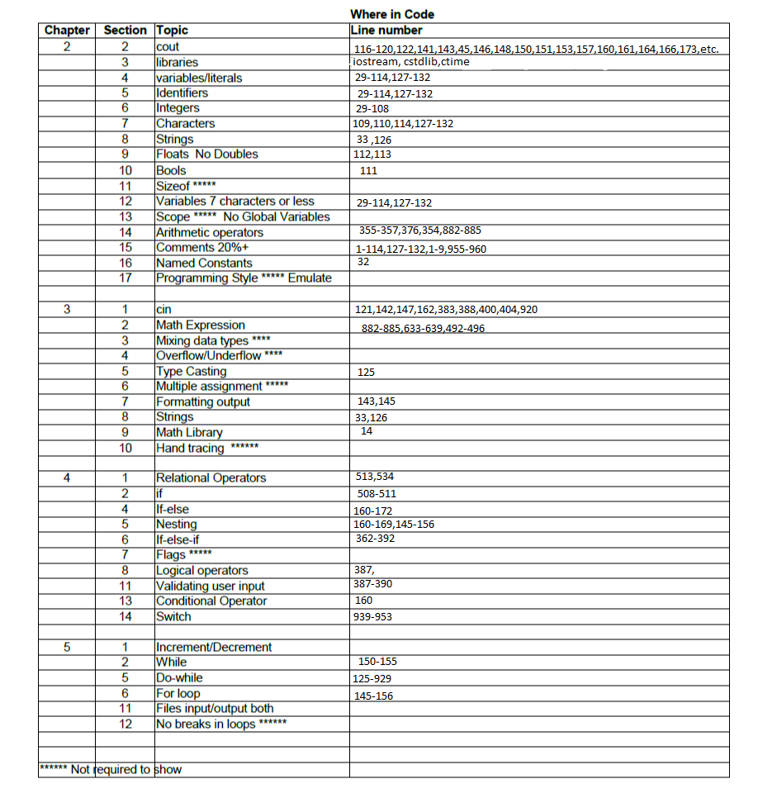

Did not include input.output files